MEET THE FOOD CREW: HISPANIC AND LATINO FLAVORS BLAST OFF TO SPACE!

DURATION
1 Lesson
1 Class period (50 min)

GRADE LEVELS
K-5

OVERVIEW

INTRODUCTION

In this engaging 50-minute elementary school lesson, students explore the surprising connection between Hispanic and Latino food traditions and the future of space exploration. They begin by meeting the “Food Crew” characters (Captain Banana, Avi the Avocado, Pia the Pineapple, and Luna the Coquí), then discover traditional meals that originated in each of the Food Crew’s home countries. They transition into learning about how astronauts grow food in space, focusing on NASA’s real-life 2021 experiment growing Hatch chile peppers aboard the International Space Station. Students then put their learning into action by designing their own space garden, choosing foods that are significant to them and discussing how culturally significant foods are important for astronauts living and working in space.

LEARNING OBJECTIVES
By the end of this lesson, students will be able to:

Identify foods from different Hispanic and Latino communities, explaining where they originated from and what ingredients are typically used.
- Describe the elements necessary for growing food in space—water, light, nutrients, and air.
- Explain how different foods can benefit astronauts in space through both nutritional and cultural significance.
- Design a “Space Garden” for a Moon colony by choosing foods that are culturally significant and creating a system that supports plant growth.

STANDARDS
Next Generation Science Standards (NGSS)
K-LS1-1
Use observations to describe patterns of what plants and animals (including humans) need to survive.
K-2-ETS1-1
Ask questions, make observations, and gather information about a situation people want to change to define a simple problem that can be solved through the development of a new or improved object or tool.
3-5-ETS1-1
Define a simple design problem reflecting a need or a want that includes specified criteria for success and constraints on materials, time, or cost.
Common Core: ELA
CCSS.ELA-LITERACY.SL.K.4
Add drawings or other visual displays to descriptions as desired to provide additional detail.
CCSS.ELA-LITERACY.SL.3.5
Speak in complete sentences when appropriate to task and situation in order to provide requested detail or clarification.
CCSS.ELA-LITERACY.L.K-5.1
Demonstrate command of the conventions of standard English grammar and usage when writing or speaking.

MATERIALS
- Student worksheets
- Drawing materials

LESSON PLAN

INTRODUCTION (15 MINUTES)
- Begin by introducing Blue Origin and Club for the Future
- Introduce Lesson and Purpose
- Warm Up Prompt: "Where does our food come from?"
- Show images of foods grown in Latin America

LESSON: GROWING FOOD IN SPACE (10 MINUTES)
- Hook Question: “How do astronauts grow food in space?”
- Growing Food in Space
  - NASA Chile Peppers on the International Space Station
  - Elements necessary to grow food

ACTIVITY: DESIGN YOUR SPACE GARDEN (25 MINUTES)
- Design a small space garden for a Moon colony
  - For K-2 students, use Page 2
  - For 3-5 students, use Page 3
- Discuss why foods were chosen and the importance of culturally diverse foods

ADDITIONAL ACCOMMODATIONS
Language Support
- Bilingual handouts with key vocabulary in both English and Spanish
- Visual vocabulary cards with images alongside text for all key terms
- Pre-teach key vocabulary before the lesson: culture, water, nutrients, light, air
- Allow Spanish responses in writing or discussion when appropriate—celebrate students' home languages as assets!
- Sentence frames on worksheets:
  - "This crop is important to ___ culture because ___."
  - "We chose ___ because it gives astronauts ___."
Visual & Auditory Support
- Use lots of images and diagrams alongside spoken instructions
- Repeat directions and check for understanding
- Provide a printed copy of the slides so students can follow along
- Subtitles/captions on any video clips shown
TIME | MATERIALS | ACTIVITY
15 min  Intro | Slides | - (Slide 1)  - Welcome students  - (Slide 2)  - Introduce yourself (for Blue Origin Club Ambassadors giving the presentation)  - (Slide 3)  - A little background information – has anyone heard of Blue Origin?  - Wait for hands.  - Who knows what they do at Blue Origin?  - Take some answers.  - Well, Blue Origin is a space company that builds rockets that take people and things to space. Their vision is to have millions of people living and working in space for the benefit of Earth.  - If you were living in space, what are some things you would need?  - Wait for hands. Take some answers.  - Those are great answers! Blue Origin is building rockets to fly people and the things they need to live and work in space.  - (Slide 4)  - Let’s watch a video about how they are doing this at  Blue Origin!  - As you saw in the video, Blue Origin is building  rockets and flying people to space… all for the  benefit of Earth.  - (Slide 5)  - Blue Origin has a 3-part mission, and do you know where you fit in? Right there in the third box, “To inspire and mobilize future generations.”  - That’s you—you’re the Next Generation! We want YOU to join our effort in making space a place where we can live and work together.  - (Slide 6)  - There are so many cool careers for you to explore in STEAM. Who knows what STEAM stands for?  - Wait for hands. Take some answers if students have any.  - Let’s say it together! The S is for Science, T is for Technology, E is for Engineering, A is for Art, and M is for Math!  - (Slides 7-9)  - If Club Ambassador is presenting, use these slides to present on your career pathway and what you do at Blue Origin.  - If teacher is presenting, skip these slides.  - (Slide 10)  - Let’s meet our food crew! They’re going to help us learn about different foods from their home countries.  - Read through each of the characters on the slide and discuss how they are each native to countries in Latin America.  - Each member of our food crew calls different parts of Latin America home. Let’s learn about foods that come from each of these places.  - (Slide 11)  - This is a tamale—corn dough filled with meat, cheese, or vegetables, wrapped in a corn husk and steamed.  - Read through the facts on the slide.  - Just like Avi the Avocado, tamales are from Mexico.  - (Slide 12)  - This is ceviche—shrimp or fish cooked in citrus juice, served with vegetables and crunchy sides, including something you might not expect… popcorn!  - Read through the facts on the slide.  - Just like Captain Banana, ceviche is from Ecuador.  - (Slide 13)  - This is gallo pinto—beans and rice fried in a skillet with a vegetable sofrito (onions, peppers, garlic, and cilantro) and served during breakfast.  - Read through the facts on the slide.  - Just like Pia the Pineapple, gallo pinto is from Costa Rica!  - (Slide 14)  - This is a mofongo—fried plantains mashed with garlic and crispy pork cracklings, and served in a dome shape.  - Read through the facts on the slide.  - Just like Luna the Coquí, mofongo is from Puerto Rico.
10 min  Growing Food in Space |  | - (Slide 15)  - If astronauts want to share these foods in space, they must have some way to grow the ingredients. How do you think astronauts grow food in space?  - Wait for hands. Take some answers.  - Those are all good ideas! NASA has a really cool system for growing food on the International Space Station.  - (Slide 16)  - NASA has grown a variety of foods on the Space Station, including Hatch chile peppers—which are pretty spicy! Do any of you like spicy foods?  - Spicy foods add flavor to a lot of Latin American dishes, but they have a special use in space…  - Astronauts’ taste buds become weaker in space because they have limited options for food. Spicy foods help wake up those taste buds! To celebrate the successful growth of their peppers, the astronauts enjoyed eating them on tacos.  - (Slide 17)  - Here’s a video to show you how the chile peppers grew in outer space. Pay attention to what seems different from how we grow food here on Earth.  - (Slide 18)  - What did you see in the video? Did it look like how we grow our food on Earth?  - Ask students to point out some ways growing food in space is different from growing food on Earth. Take some answers.  - Those are some great observations! You all are thinking like scientists.  - In order to grow plants anywhere, we need certain things: water, nutrients, light, and air. These resources are not available in space like they are on Earth, so scientists had to come up with a new way to grow plants on the Space Station!  - NASA scientists and astronauts have developed ways to save water, provide light and nutrients, and regulate air for plants in space. Isn’t that so cool?
25 min  Design Your Space Garden |  | - (Slide 19)  - Astronauts may be able to grow food on the Space Station, but we want to take it even further—to the Moon and even one day to Mars. Today we’re going to think like scientists and come up with ways to grow food on the Moon!  - Hand out student worksheets. Consider having students work in groups to design a space garden together.  - You’re going to design your own space garden. In order for food to grow, your garden needs to have sources of water, light, and air. You also need to create a way to give the plants nutrients.  - Your garden should include different foods that your family eats at home. While you’re drawing, think about what makes these foods special. Does your family use them for a special meal like the ones we learned about?  - Allow students 20 minutes to work on their space gardens.  - After 20 minutes, call on 2-3 students or groups to share their space garden designs. Ask them how they included each element necessary for food to grow.  - These are great designs! Just like you all, scientists are working right now to develop new ways to grow food in space. One day you could join them and design a system to grow food on the Moon!  - Why is it important that astronauts can enjoy meals from all different cultures?  - Take some answers.  - Those are great answers! Eating meals from different cultures can help astronauts feel at home even when they’re far away. One day, you could join scientists in creating a habitat that grows food on the Moon, so astronauts can enjoy their family meals in space too!
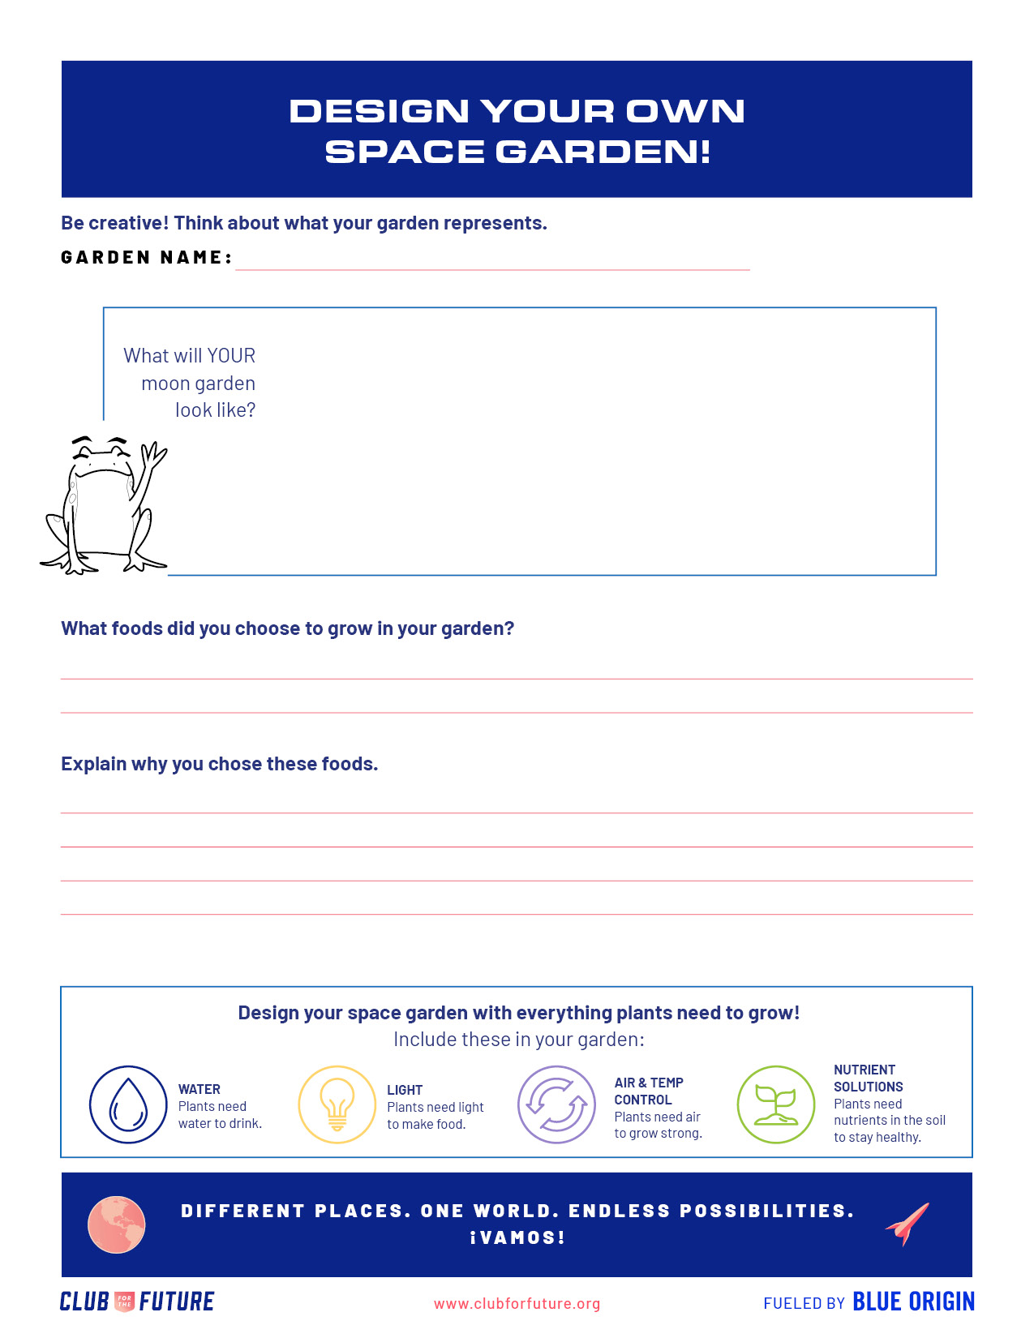

STUDENT WORKSHEETS

