From Milpa to Mars: Hispanic & Latino Food Culture and The Future of Space Farming

DURATION
1 Lesson
1 Class period (50 min)

GRADE LEVELS
6-8

Overview

Introduction

In this engaging 50-minute middle school lesson, students explore the surprising connection between Hispanic and Latino food traditions and the future of space exploration. They begin by reflecting on foods that remind them of family and home, then dive into the cultural significance of dishes like tamales, mole, and pupusas, the 9,000-year-old Indigenous wisdom of the "Three Sisters" (maize, beans, and squash), and NASA's real-life 2021 experiment growing Hatch chile peppers aboard the International Space Station. Students then put their learning into action through a collaborative group activity called "Design Your Space Milpa," where teams of 3-4 design a small space garden for a Mars colony by selecting three culturally significant Hispanic and Latino crops, explaining their cultural and nutritional value, and creatively naming their garden before sharing in a lightning-round presentation.

Learning Objectives
By the end of this lesson, students will be able to:

1. Explain the cultural significance of food in Hispanic and Latino communities by identifying at least three traditional dishes and connecting them to family, identity, and heritage.

2. Describe the "Three Sisters" and milpa farming system as an example of Indigenous scientific knowledge that demonstrates symbiotic relationships among organisms.

3. Analyze the role of food in human well-being, including its impact on physical nutrition and emotional/cultural health—particularly for astronauts in space.

4. Design a sustainable "Space Milpa" for a Mars colony by selecting culturally significant crops and justifying their choices using both cultural and nutritional evidence.

Standards
Next Generation Science Standards (NGSS)
MS -LS2-5
Evaluate competing design solutions for maintaining biodiversity and ecosystem services.
MS-ESS3-3:
Apply scientific principles to design a method for monitoring and minimizing a human impact on the environment.
Common Core: ELA
CCSS.ELA-LITERACY.SL.6-8.1
Engage effectively in a range of collaborative discussions with diverse partners on grade-appropriate topics, building on others' ideas and expressing their own clearly.
CCSS.ELA-LITERACY.L.6.1
Demonstrate command of the conventions of standard English grammar and usage when
writing or speaking.
CCSS.ELA-LITERACY.L.6.2
Demonstrate command of the conventions of standard English capitalization, punctuation, and
spelling when writing.

Materials
- Student worksheets
- Drawing materials
- Poster paper

Lesson Plan

Introduction (15 minutes)
- Begin by introducing Blue Origin and Club for the Future
- Introduce Lesson and Purpose
- Warm Up prompt: "What food reminds you of family or home?"
- Show 2-3 images of traditional Hispanic and Latino dishes (tamales, mole, pupusas)
- Hook question: "Could astronauts eat these foods in space?"

Mini-Lesson Part 1: Food as Culture (10 minutes)
- Food as Identity
  - Family, holidays, and traditions (Día de los Muertos, Navidad)
  - Regional diversity across Mexican, Caribbean, Central & South American cultures
- The "Three Sisters" of Mesoamerica
  - Maize, beans, and squash — foundational crops grown together for thousands of years
  - Introduce the milpa farming system (Indigenous agricultural wisdom)

Mini-Lesson Part 2: Bridge to Space Farming (10 minutes)
- Why Grow Food in Space?
  - Long missions to the Moon and Mars need fresh food
  - Mental/emotional benefit of familiar flavors far from home
- Real Example: Chiles in Space!
  - In 2021, NASA grew Hatch chile peppers on the ISS
  - Astronauts chose them for flavor, nutrition, AND cultural familiarity
  - Connect: traditional Hispanic and Latino crops could shape the future of space agriculture

Activity: "Design Your Space Milpa" (18 minutes)
Group activity (3-4 students per group):
Design a small space garden for a Mars colony that:
- Includes 3 culturally significant Hispanic and Latino crops
- Briefly explains why each crop was chosen (cultural + nutritional)
- Garden Name
Time breakdown:
- Design & discuss: 12 minutes
- Lightning-round share-out: 6 minutes (30 seconds per group)
Materials: Simple worksheet, colored pencils, crop reference sheet

Wrap-Up & Exit Ticket (7 minutes)
Quick Class Discussion (4 min):
- How does growing familiar foods help astronauts feel "at home" in space?
- Why is preserving cultural food traditions important, even in new frontiers?
Exit Ticket (3 min):
- "Write one sentence about how Hispanic and Latino food traditions could influence the future of space exploration."

Additional Accommodations
Language Support
- Bilingual handouts with key vocabulary in both English and Spanish
- Visual vocabulary cards with images alongside text for all key terms
- Pre-teach key vocabulary before the lesson: culture, identity, nutrition, agriculture, colony, sustainable
- Allow Spanish responses in writing or discussion when appropriate—celebrate students' home languages as assets!
- Sentence frames on worksheets:
  - "This crop is important to ___ culture because ___."
  - "We chose ___ because it gives astronauts ___."
Visual & Auditory Support
- Use lots of images and diagrams alongside spoken instructions
- Repeat directions and check for understanding
- Provide a printed copy of the slides so students can follow along
- Subtitles/captions on any video clips shown
TIME | MATERIALS | ACTIVITY
15 min  Intro | Slides | - (Slide 1)  - Welcome students  - (Slide 2)  - Introduce yourself (for Blue Origin Club Ambassadors giving the presentation)  - (Slide 3)  - A little background information - anyone heard of Blue Origin?  - Wait for hands.  - Who knows what they do at Blue Origin?  - Take some answers.  - (Slide 4)  - Well, Blue Origin is a space company that builds rockets that take people and things to space. Their vision is to have millions of people living and working in space for the benefit of Earth.  - What are ways we could utilize space to benefit  Earth?  - Wait for hands. Take some answers.  - Those are great answers!  - Let’s watch a video about how they are doing this at  Blue Origin!  - As you saw in the video, Blue Origin is building  rockets and flying people to space… all for the  benefit of Earth.  - (Slide 5)  - Blue Origin has a 3-part mission, and as you can see,  the third mission is “To inspire the Next Generation,” that’s where all of you come in.  - If we are to have millions of us living and working in space, it's going to take a lot of time and brain power and it's not going to happen in just my lifetime.  - We need you to help us take on this mission and help us build this life in space.  - (Slide 6)  - And that’s where Club for the Future comes in. Club for the Future is the non-profit created to complete that third part of the mission and that is where I come in today as a Club Ambassador.  - (Slides 7-9)  - If Club Ambassador is presenting, use these slides to present on your career pathway and what you do at Blue Origin.  - If teacher is presenting, skip these slides.  - (Slide 10)  - Today we're going on a journey that connects two things you might not expect to go together: the foods our families have been cooking for thousands of years… and outer space.  - (Slide 11)  - Before we dive in, I want you to think about this question: Food is more than nutrition—it's identity, memory, and history. What's a food that carries cultural meaning for you or your community, and why? What food reminds you of family or home? Maybe it's something your grandma makes on holidays, or a dish that fills the kitchen with a smell you'd recognize anywhere.  - Turn to the person next to you and share. You've got about one minute—go!  - Circulate while students talk to listen for great responses.  - Call on 2-3 volunteers afterward.  - Affirm all answers — there's no wrong response.  - (Slide 12)  - Let's look at a few dishes that come from different Latin cultures. This is a tamale—corn dough filled with meat, cheese, or vegetables, wrapped in a corn husk and steamed. Families gather to make dozens at a time.  - This is mole—a rich, complex sauce that can have over 20 ingredients, including chiles and even chocolate.  - And these are pupusas—a thick, stuffed flatbread from El Salvador and Honduras.  - (Slide 13)  - Here's my big question for you today: Could astronauts eat these foods in space? Hold on to that thought, because we're going to come back to it.  - Don’t let them answer yet, let curiosity build.  - This is the main question throughout the lesson.
10 min  Food as Culture |  | - (Slide 14)  - Food in Hispanic and Latino cultures isn't just about eating—it's about identity. It's how families pass down stories, celebrate, and remember the people they love.  - Think about Día de los Muertos. Families build altars with their loved ones' favorite foods—pan de muerto, tamales, mole. The spirits come back to visit, and the food welcomes them home.  - Or Navidad. In many Hispanic and Latino families, making tamales together is a tradition where everyone has a job. It's a whole evening of family.  - And here's something important: 'Latino' isn't just one culture. It includes Mexico, Cuba, Puerto Rico, the Dominican Republic, Guatemala, Honduras, El Salvador, Colombia, Venezuela, Argentina, Peru—and many more. Each country and region has its own dishes, ingredients, and traditions.  - So food isn’t just food. Food represents family, history, and identity.  - (Slide 15)  - Let's travel back in time. Thousands of years ago, Indigenous peoples in what we now call Mexico and Central America discovered something incredible. Three crops that grow better together than apart: maize, beans, and squash. We call them the Three Sisters.  - Here's why it's genius: Corn grows tall and gives the beans something to climb. Beans put nitrogen back into the soil. Squash spreads big leaves that keep the soil moist and block weeds. Three plants working as a team to grow better and thrive.  - This is indigenous science at work.  - (Slide 16)  - This system is called the milpa. It's not just farming—it's a whole way of thinking about how plants, people, and the Earth work together. And it's been used for over 9,000 years. That's older than the pyramids in Egypt!  - Why do you think it's important that these crops support each other? What does that tell us about Indigenous farming knowledge?  - (Slide 17 or 18)  - Let’s look at a video that dives more in depth into the topic.  - Show either video, it is your choice depending on your students.  - The TED Talk one talks more about the science of how the Milpa farming system works, three sisters, and the history of it in visual form (~5min)  - The second is in Spanish and talks about Milpa farms and its significance to people (~5min)
5 min  Bridge to Space Farming |  | - (Slide 19)  - Now let’s take a look at food in space.  - Imagine you're an astronaut chosen for a mission to Mars. The trip alone takes 7 to 9 months one way. You'll be away from Earth for years. What are you going to eat?  - Right now, astronauts eat pre-packaged, freeze-dried food. After months, it gets old—imagine astronaut mac-and-cheese every day for two years!  - (Slide 20)  - Astronauts did get tired of the same old food and started to figure out other things they could grow. In 2021, NASA grew chile peppers on the International Space Station—specifically, Hatch chile peppers from New Mexico.  - Why chiles? One: They're packed with Vitamin C. Two: Astronauts lose some sense of taste in space, so spicy food wakes up their taste buds. Three—my favorite part: Astronauts wanted chiles because they're culturally meaningful. They connect to home.  - Think about that. NASA—rocket scientists—chose what to grow in space partly because of culture. Hispanic and Latino food traditions are literally shaping what humans eat on the Moon and on Mars.  - (Slide 21)  - So back to our big question: Could astronauts eat these kinds of foods in space? What do you think now?  - Maybe not exactly the way your abuela makes them—yet. But the ingredients? The corn, the beans, the chiles? Those could absolutely be grown in space. And that's where YOU come in.
18 min  Design Your Space Milpa | Student worksheet  Crop reference sheet | - (Slide 22)  - Pass out student worksheet and crop reference sheet.  - Alright, here's your mission. You're working in groups of 3 or 4 to design a small space garden for a Mars colony. I'm calling this your Space Milpa.  - You are designing it like a traditional milpa where you have to think about what plants to grow that would best support each other and the whole garden.  - Here's what your garden needs. Step One: Pick three culturally significant Hispanic and Latino crops. Use the Crop Reference Sheet I'm passing out for ideas—you'll see corn, beans, squash, chiles, tomatoes, avocados, quinoa, and more.  - Step Two: For each crop, write a short reason why you chose it. Think about both culture—why does this crop matter to people?—and nutrition—what does it give the body?  - Step Three: Create a poster with your crops. If you have time, show us how you would be growing this in space. What does the actual space garden look like?  - Step Four—my favorite part: NAME your garden! Be creative. Make it cool. Make it meaningful. Bonus points for a name that tells a story.  - You'll have 12 minutes to design and discuss. Then each group will get 30 seconds—a lightning round—to share with the class. Quick, snappy, and fun.  - Any questions? Great—get into your groups and get started!  - Circulate during work time and ask probing questions:  - "Why did you pick that crop? What makes it special?"  - "How do these crops work together, like the Three Sisters?"  - "What's the story behind your garden's name?"  - (Slide 23)  - Time! Let's do our lightning round. Each group has 30 seconds to share. Tell us your garden's name, your three crops, and one quick reason why you chose them.  - Give brief affirmations between groups: "Love that name!" "Great science thinking!"  - If time runs short, ask groups to share just the garden name + crops.  - (Slide 24)  - Amazing work, everyone. I love the creativity and the thinking behind every garden.  - Let's pull this all together. I have two big questions for you.  - First: How does growing familiar foods help astronauts feel 'at home' in space?  - Take some answers  - Second: Why is it important to preserve cultural food traditions—even when we're heading to brand new places like Mars?  - Take some answers.  - When humans go to Mars—and we WILL go to Mars in your lifetime—we won't just be bringing rockets and robots. We'll be bringing culture. We'll be bringing stories. We'll be bringing the foods our great-great-grandparents grew thousands of years ago.  - The milpa your ancestors planted could become the milpa on Mars. That's a beautiful thing to think about.  - (Slide 25)  - If the teacher wants to do the exit ticket, do it, or skip it.  - Or can do exit ticket question on “Art to Space” platform and send to space https://draw.clubforfuture.org/  - Before you leave, I want one sentence from you. Here's your prompt: Write one sentence about how Hispanic and Latino food traditions could influence the future of space exploration.  - Just one thoughtful sentence. Hand it to me on your way out.  - Thank you all for an awesome class today. Remember: the future of space isn't just about technology—it's about who we are, what we eat, and the cultures we carry with us.

Student Worksheets

Name___________________________________________________ Date _______________________ Period_______

Mars Milpa Garden
Be creative! Think about what your garden represents.
Garden Name: ____________________________________________________

Choose Your 3 Crops
Use the Crop Reference Sheet to help you decide. Pick crops that are culturally meaningful AND nutritionally valuable.

🥇 Crop #1
Crop Name: ______________________________________
Why is this crop culturally significant?

What nutrients does it provide?

🥈 Crop #2
Crop Name: ______________________________________
Why is this crop culturally significant?

What nutrients does it provide?

🥉 Crop #3
Crop Name: ______________________________________
Why is this crop culturally significant?

What nutrients does it provide?

🎨 Sketch Your Space Milpa!
Draw your garden on a poster. Show how your crops will be arranged. Will they grow together like the Three Sisters? Add labels!

🚀 Get Ready to Share!
In 30 seconds, your group will share with the class. Use this template to plan what you'll say:
"Our garden is called __________________________. We chose __________, __________, and __________ because ____________________________________."

💡 Sentence Starters (If You're Stuck!)
- "We chose ______ because it represents…"
- "This crop is important to ______ culture because…"
- "Astronauts would love this crop because…"
- "These crops grow well together because…"

Crop Reference Sheet
Traditional Hispanic and Latino Crops for Your Space Milpa
Crop Name | Cultural Significance | Nutrition | Growing Notes
MAÍZ (CORN)  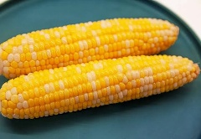 | The heart of Mesoamerican civilizations for over 9,000 years. Sacred in Mayan and Aztec cultures. Used in tamales, tortillas, pozole, and arepas. | Carbohydrates for energy, fiber, B vitamins. | Tall plant — great for supporting climbing crops!
FRIJOLES (BEANS)  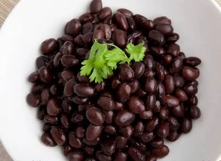 | A staple food across all Latin American cultures. Black beans, pinto beans, and red beans are everyday foods in Mexico, the Caribbean, and Central America. | High in protein, iron, and fiber. | Adds nitrogen to the soil — helps other plants grow!
CALABAZA (SQUASH)  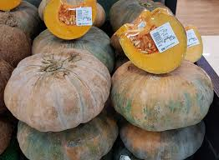 | One of the oldest crops in the Americas. Used in soups, stews, and even desserts like calabaza en tacha. | Vitamin A, Vitamin C, fiber. | Big leaves cover the ground, keeping soil moist and blocking weeds.
CHILE PEPPERS  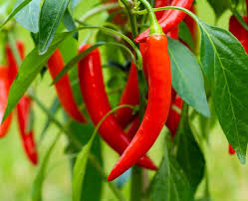 | Essential in Mexican, Caribbean, and Central American cooking. Already grown in space by NASA in 2021! | Vitamin C, Vitamin A, antioxidants. | Compact plants — perfect for small spaces like a Mars greenhouse!
TOMATE (TOMATO)  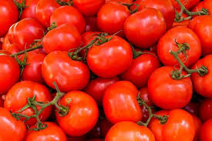 | Originally from the Americas! Foundational in salsas, moles, and sofritos across Hispanic and Latino cuisines. | Vitamin C, lycopene, potassium. | Needs sunlight and support — like a trellis.
AGUACATE (AVOCADO)  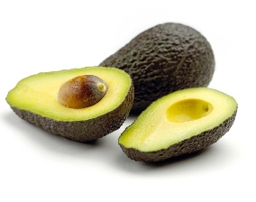 | Native to Mexico and Central America. Used for thousands of years; essential in guacamole and many traditional dishes. | Healthy fats, fiber, potassium, Vitamin E. | Grows on a tree — would need a tall greenhouse!
QUINOA  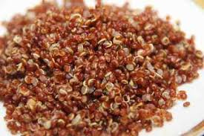 | A sacred grain of the Andes (Peru, Bolivia, Ecuador). Cultivated by the Incas for over 5,000 years. | Complete protein (rare in plants!), iron, magnesium. | Hardy plant that tolerates tough conditions — great for Mars.
AMARANTO (AMARANTH)  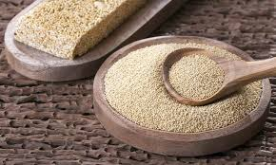 | Sacred to the Aztecs. Used in alegrías (a traditional sweet) and as a grain. | High in protein, iron, calcium. | Drought-resistant and grows quickly.
BATATA (SWEET POTATO)  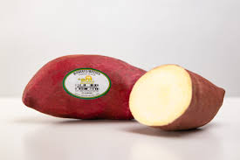 | Originated in Central and South America. Important in Caribbean and South American cuisines. | Vitamin A, Vitamin C, fiber, potassium. | Grows underground — saves space above!
CACAO  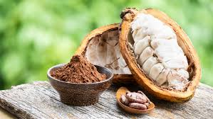 | Sacred to the Maya and Aztecs — used in ceremonies and as currency. The original source of chocolate! Used in mole. | Antioxidants, magnesium, iron. | Needs warmth and humidity — would need a special greenhouse zone.
ACHIOTE (ANNATTO)  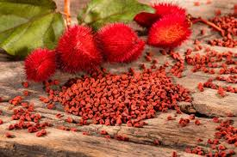 | Used in Caribbean, Mexican, and Central American cooking for color and flavor (like in cochinita pibil). | Antioxidants, Vitamin E. | Small shrub — fits well in compact spaces.
CHIA  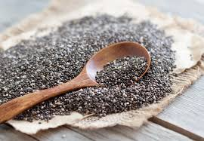 | Cultivated by the Aztecs for energy and endurance. | Omega-3 fatty acids, fiber, protein. | Small plant, easy to grow.

